

American International University-Bangladesh (AIUB)  
**Department of Computer Science  
Faculty of Science &Technology (FST)  
Spring 21-22**

**The Buying House**

Software Requirement Engineering

Sec: **A**

Project submitted

By

*Arefin, Md. Salman (18-38698-3)*

*Rahman, MD. Meshkatur (18-38672-3)*

*Tarek, Md. Shohidul Islam (18-38690-3)*

Contents

1. PROBLEM DOMAIN 1

1.1 Background to the Problem 1

1.2 Solution to the Problem 1

2. SOLUTION DESCRIPTION 2

2.1 System Features 2

2.1.1 User Registration 2

2.1.2 Login interface: 2

2.1.3 Searching 3

2.1.4 Product status (available or not) 3

2.1.5 Cost 3

2.1.6 Payment 3

2.1.7 Delivery Status: 3

2.1.8 Feedback 4

3. UML Diagrams 4

3.1 Use Case diagram 5

3.2 Class diagram 5

3.3 Activity Diagram 6

3.4 Sequence Diagram 9

3.5 ER diagram 10

4. Social Impact 11

5. Project Estimation 12

6. Project Schedule 13

7. Development Plan 15

7.1 Stage 1: Requirement Analysis & Defining 16

7.2 Stage 2: Designing the Product Architecture 16

7.3 Stage 3: Building or Developing the Product 16

7.4 Stage 4: Testing the Product 16

7.5 Stage 5: Deployment and Maintenance 16

7.6 Stage 6: Review 17

8. Change Management Plan 18

9. Marketing Plan 19

9.1 Marketing Strategy for the Short Term: 19

9.1.1 Marketing on the Internet: 19

9.1.2 Advertisements in the media: 19

9.2 Marketing Strategy for the Long-Term: 20

9.2.1 Campaigns: 20

9.2.2 Billboards: 20

9.2.3 Search Engine Optimization (SEO): 20

9.3 Plan for Consistent Marketing: 20

9.3.1 Account on social media: 20

9.3.2 Promotional Film: 21

10. Cost and Profit Analysis 21

10.1 Development cost: 21

10.2 Marketing Cost: 21

10.2.1 Short Term Marketing Cost: 21

10.2.2 Long Term Marketing Cost: 21

10.2.3 Continuous Marketing Cost: 22

10.3 Profit: 22

10.4 Analysis: 22

11. Reference 23

# 

# PROBLEM DOMAIN

## Background to the Problem

There are many Garments and Buying house in Bangladesh. Garments can directly receive the order and deliver the products to the clients. But the buying house plays a role of mediator between buyer and manufacturer. So basically buying house communicates with buyers of the other countries who want to buy garments products.

The root reason of the problems are when ordering products, mainly Foreign buyers depend on buying house as they have less or no idea of right manufacturers to place an order. Manufacturers are also depending on buying house to get orders from them. In this way, the buying house creates a contract between the buyer and the factory. In this way buyers are cheated by the buying house because the buying house collect a huge amount of money from the clients but the real production cost are not that much. Buying house earned a lot from the customer but they do not pay taxes to the government. Many times they do not maintain time, and do not deliver the products on time.

The problem is so important to consider, because we want to create a online based software which will be very user friendly for the buyers as well as the factories. Our software will also make the global popularity of all the garments factories in all over the world. By using our software buyers will find the best factories, they can communicate with them, they can place an order and purchase their product with a great pricing and as well as the garments can directly receive the order and deliver the products to the clients. And this way there is no possibility of cheating the buyers and also the seller will not be able to evade taxes. Buyers will find out how much a garments factory can charge for their products in all over Bangladesh.

## Solution to the Problem

This solution of the problem is to use online based buying house software. Garments factories will already be on the list in our software so that when the buyers want to buy the products, they will see the garment factories in their list. So that they can easily find the garment factories without facing any problem. There will be direct transactions between the buyers and sellers so there will be no possibility of fraud in any parties. The sellers will not be able to evade taxes because the taxes will be added directly to the government sector because we have online payment section and also a payment database where every transaction will be recorded. Buyers can fix the delivery time when ordering the product. So that order has to be delivered within that time so there will be no delivery issue. If the garments factory fails to deliver the product on time, then they will have to pay a fine. The solution is feasible to the meet the business objective.

In our software buyers and sellers have individual user id and password to access their account section, advertising section for buyers-they will add according to their needs, message section for their conversations, confirmation section in database, tax section, payment section and timing section for buyers to set their delivery time. And the special features in our software are the rating and commenting section where buyers can rate and comment the garments factories works after delivery. Buyers do not have to go though a third party to place an order. We will get 0.5% profits per contract from this software. The goal of our software is to make the Bangladeshi garment factories known worldwide and connecting garment factories all around the world with our software in the future.

# SOLUTION DESCRIPTION

## System Features

### User Registration

* + The software will provide an interface for the buyers and sellers to login. Beside the login

button there will be an option for new user registration or sign up option.

* When the sign-up option is pressed then buyers can sign up in buyer requirements and sellers can sign up in seller requirement.
* the user will be taken to a new page and there will be a form that needs to be filled as a buyer or seller.
* The user will need to provide his or her name, mail address, mobile number, address, photo and NID number. Then user need to give an user name password for that use account.
* Immediately the system will give him/her a random verification code and send it to the user phone number. User will need to verify while logging for the first time.

Priority Level: High

Precondition: User must have a valid phone number, email address and have to provide authentic personal information.

### **Login interface:**

* The software will provide and interface for the user to login to the system using their user’s name and password.
* After login attempt the user will be taken to the home page.
* Three wrong attempts of login the user shall be blocked for any further login attempts for next 30 minutes.
* If the user forgot his/her password then random verification code sent to his phone number by the system authority and then the system will prompt for the new password.

Priority level: High

Precondition-User must have a valid user id, password and phone number.

### Searching

* The software shall allow users to search about the desired information.
* If searching data do not exist the software will show do not exist notification.

Priority Level: High

Precondition: User must have a valid user id and password.

### Product status (available or not)

* This feature will give an indication to the users whether the product is available or not.
* If the product is available then the feature will request the buyers to provide the quantity. Based on the quantity the buyers will add the price into the system and then show the price and delivery date in the following page.

Priority Level: High

Precondition- User must have searched for a particular product.

### Cost

* System will get 0.05 % profit for every contract.
* buyer needs to pay taxes also.
* This tax will add in the payment section or total cost and you have to pay this profit.

Priority Level: High

Precondition: User must have to pay tax.

### Payment

* The user can pay through online banking, debit card or bkash.
* Customer will also need to provide an address where the product will delivered.

Priority Level: High

Precondition: User must have some items in the chart.

### Delivery Status:

* This feature will allow the user to see the current status of the product.
* After finish the delivery the delivery status will be “delivered”.

Priority Level: Medium

Precondition: An order should be placed earlier.

### Feedback

* It is very important feature of this software. The system will get direct feedback from buyers. Depending on the feedback the system can decide how to modify or improve

For better user experience.

Priority Level: Low

Precondition: User must have purchased some items from the system.

# UML Diagrams

Buyers can buy products without any help of the third party. They will have everything in this software. For sellers and buyers if they have already their user id and password then they can go for the next step which is system home page. Otherwise if they don’t have any user id or they are new in this platform they have to go for the sign-up option. There buyers and Sellers can find out which one is appropriate for them. In this software buyers can sign up in buyer requirements and sellers can sign up in seller requirement. But there they have to fill-up their personal information like names, mail address, phone no, address, photo and NID card. And also, they have to give an user id and password for their profile. System provides a verification code through phone because of the security purpose. If the confirmation is done, they can log in into the system and go for the homepage. On the other-hand if Registered buyers and sellers give wrong password into the system, they shall be blocked for any further login attempts for next 30 minutes. By going to the homepage, buyers will get the search option and they will search the data according to their needs. If the data is in the system then it with show otherwise If its nit then no data exists will show. If the data is available as needed the system will ask buyers how much products quantity they required. After those buyers will give their desire price and delivery time of the product as per their requirements in the system. If the seller has the required product available or they can make required products, then he/she will talk to the buyers directly and confirm the order and also buyer will discuss about when he wants to make the payment. He can pay through online banking, debit card or mobile banking. Once the order is confirmed the system will ask the buyer for the delivery address where the shipment will be delivered.

## Use Case diagram

A use case diagram is a way to summarize details of a system and the users within that system. It is generally shown as a graphic depiction of interactions among different elements in a system. Use case diagrams will specify the events in a system and how those events flow, however, use case diagram does not describe how those events are implemented.

In Use Case diagram there are 3 actor will be performed. Registered Buyer, Registered Seller, System as Admin. Registered Buyer will make a chain with non-registered buyer where if they want to register later then they can register as well. Same process will be for non-registered seller. For registration or sign up Clients and Manufacturer, they have to give their some Personal Information like Photo/Logo, Name, Email, NID, Phone No, Address. After register, they will get User Name, Password and verification code. Now Only for Registered Buyer after logging, they can search by system. If the data exist then buyer can order and payment with 4 different types. They are Online Booking, Debit card, Mobile payment, Add price/Deliver. and also buyers can request quantity by system. But if the requirement does not match then they can cancel the order. Finally after giving Delivery Address by Registered Buyer System will store data and seller will deliver the product on time at that address.

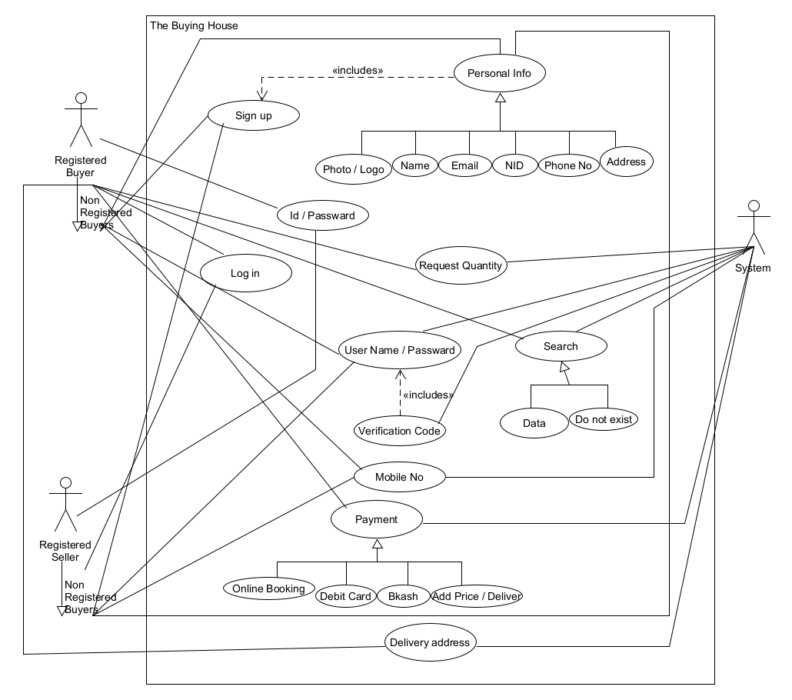

**Figure 1-Use case diagram**

## Class diagram

A class diagram in the Unified Modeling Language (UML) is a type of static structure diagram that describes the structure of a system by showing the system's classes, their attributes, operations (or methods), and the relationships among objects.

In this, Class Diagram Buyers and Sellers have 3 attributes (Name, Phone and Address). System has only 1 attribute which is Login. Delivery has Address and Time attribute and Order has 4 attribute (Data, Status, Total Amount, Total Tax). Order Details has 2 new different attributes which are Quantity and Tax Status. Item has also 2 different new attributes Shipping Weight and Description. Payment has only Amount. Online has also only Number. Debit-card and Mobile Banking has same attribute they are Number and Type. Finally, Product has 2 attribute which are Available and In Stock.

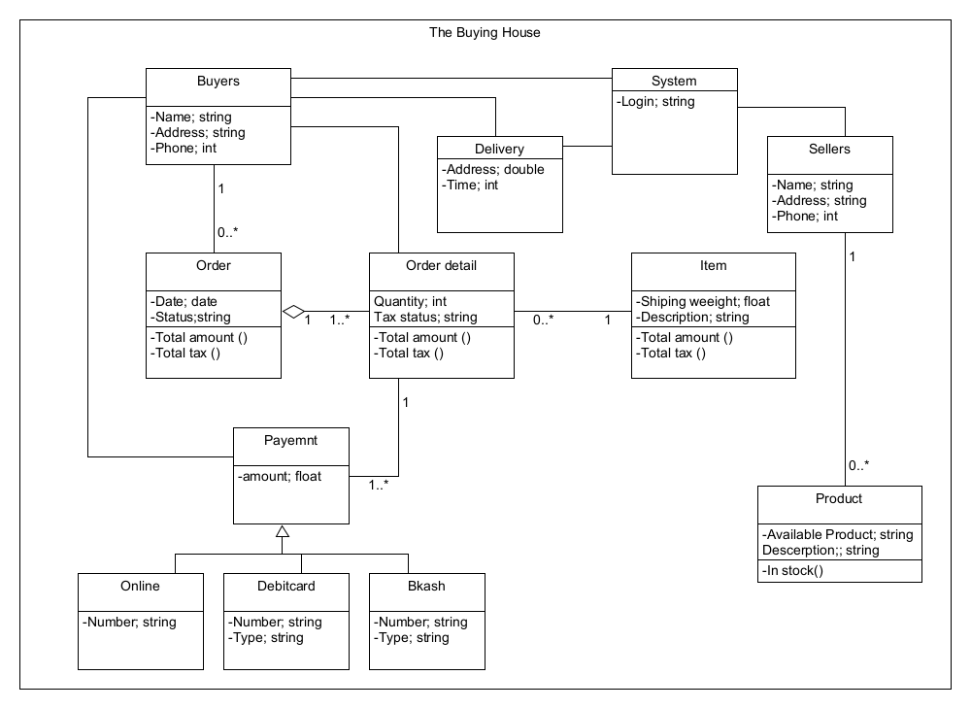

**Figure 2-Class diagram**

## Activity Diagram

Activity diagram is basically a flowchart to represent the flow from one activity to another activity. The activity can be described as an operation of the system. Activity is a particular operation of the system. Activity diagrams are not only used for visualizing the dynamic nature of a system, but they are also used to construct the executable system by using forward and reverse engineering techniques. The only missing thing in the activity diagram is the message part.

Activity Diagram will be start from Login step. If Buyers and Sellers are not registered the system will take their in Sign Up page. After giving Personal Information, Set User Name, Verification code they will be registered. If not then the system will take them again Sign up page for doing that again. After Registration they can access to the system and then they will get ID and Password. After Login they can search data from the store. If they get their product then system can show data and buyers can request for quantity, show quantity and finally they can order and payment. But if they don’t get product from store then buyers can change the manufacturer. Finally after order and payment the procedure will be finished.

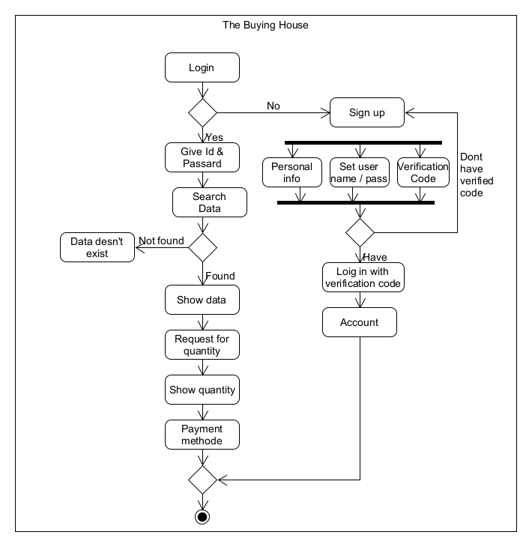

**Figure 3-Activity diagram**

## Sequence Diagram

Sequence Diagrams are interaction diagrams that detail how operations are carried out. They capture the interaction between objects in the context of a collaboration. Sequence Diagrams are time focus and they show the order of the interaction visually by using the vertical axis of the diagram to represent time what messages are sent and when.

In Sequence Diagram Buyer and Seller have to sign up by giving information. Then the system will store their data. After storing data system will generate verification code. Buyers will provide verification to the system and system will create account. After creating, an account a confirmation message will be send to the buyers. Same procedure will be followed for the sellers. After confirmation message buyers and sellers can be login with ID and Password. After Login buyers can give their quantity info. System will store and provide the quantity to the sellers. If the sellers have quantity then the seller will inform to the system and system will auto give a feed back to the buyer. If the quantity is not available then the seller will provide the negative feed back to the system and system will give it to the buyers that the quantity is not available. If it is available then buyer can confirm the order with providing delivery details and advance payment as well. System will store advance payment and delivery info. After this confirmation, a message will be send to the buyers from the system and also seller for security purpose. After the delivery buyers can give a feedback of sellers to the system and system will store and show the feedback to others.

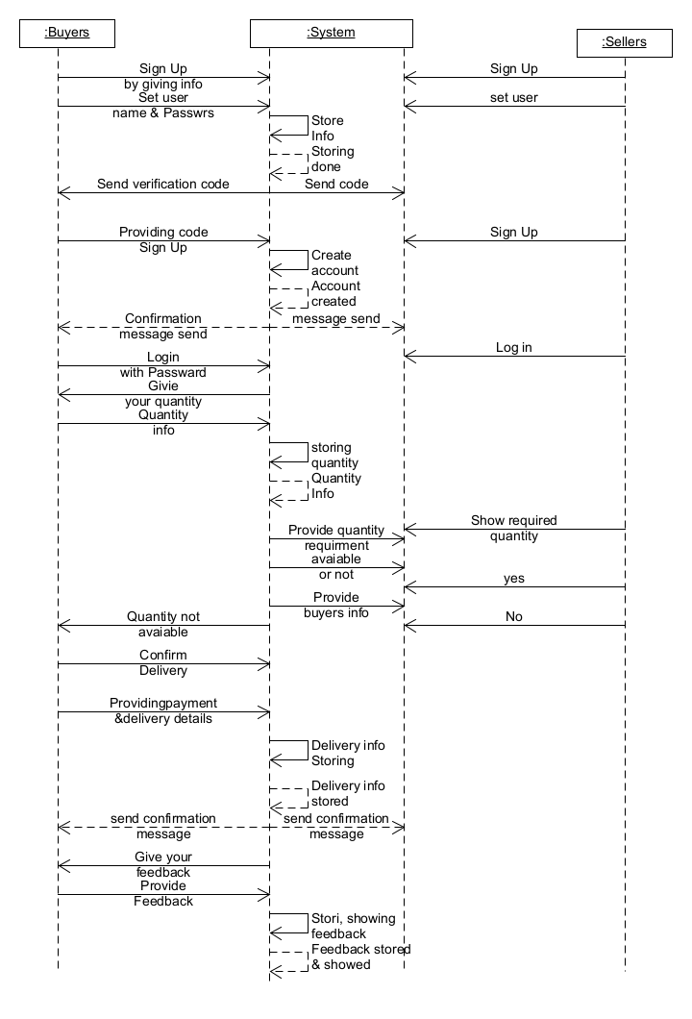

**Figure 4-Sequence diagram**

## ER diagram

ER Diagram stands for Entity Relationship Diagram, also known as ERD is a diagram that displays the relationship of entity sets stored in a database. In other words, ER diagrams help to explain the logical structure of databases. ER diagrams are created based on three basic concepts: entities, attributes and relationships.

In the ER Diagram there are 3 entity seller, buyer and system. For buyers and sellers there there are 2 unique identifier which are called key attribute. They are User ID Mobile no. Others attributes are Email, Address, Name, Logo. This is for seller and for buyers Photo, NID, Email, Address, Name. Both buyers and sellers has a specific profile. System has 4 attributes. They are Request quantity, Payment method, Delivery and Search. Both of buyers and sellers have a relationship between registered and non-registered condition.

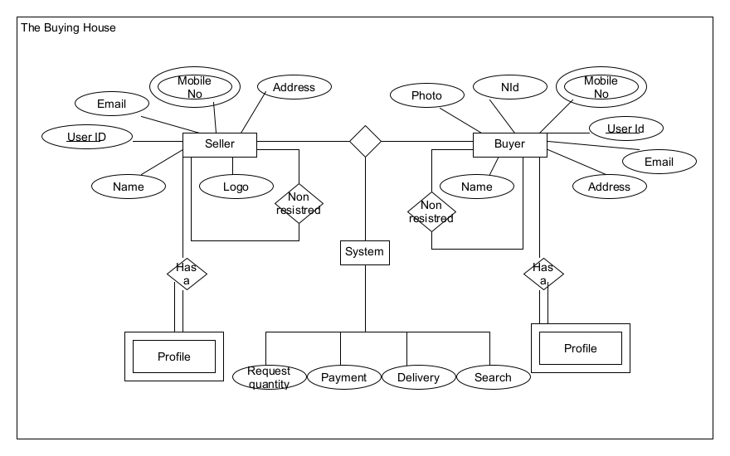

**Figure 5-ER diagram**

# Social Impact

As of 2016, Bangladesh held the **2nd place** in producing garments just after China. Bangladesh is the world's second-largest apparel exporter of western fast fashion brands.

As a beginning of the part of a popular sector, Bangladesh can growing up in Garments world day by day. To take Bangladesh in 1st place in producing garments we are developing our online-based platform named “The Buying House” where foreign client can communicate directly with manufacturers. Client do not need to search the best manufacturer and best deals because manufacturers will share the best deals and details about product by our system. Buyers will find out how much a garments factory can charge for their products in all over Bangladesh. This will be saves a lots of time for the clients. Every transaction data from manufacturer and buyers are stored in the application, so that no one can evasion the Tax. That’s why the revenue of Bangladesh will be increased properly. Sometimes buying house delay a lot of time to deliver the products to the foreign clients that’s why they cut the communication with Bangladeshi RMGs. For this kind of problems, we suggest our online-based platform where every data will be stored like delivery time, shipping information etc, so that foreign client get their products in their preferable time. If the manufacturer delay to deliver the product then the client can take legal action against the company manufacturer. For this reason, the relationship between the foreign client and the manufacturer of Bangladesh will be strongly established and Bangladeshi RMGs popularity will be increased in front of the world and the industry will grow up to the next level. This will also supportive for our revenue and remittance sector in Bangladesh.

# Project Estimation

To develop this project we need 1 Sr. Manager, 1 Sr. Analyst, 1 Analyst, 1 Ui/Ux Designer, 3 Developers (1 leader), 3 Quality Assurance Engineer (1 Leader). We need 801 hours from 7th march,2022 to 16th May,2022 to develop this project. The costing will be $55,420.00 USD.

|  |  |  |  |  |  |  |  |
| --- | --- | --- | --- | --- | --- | --- | --- |
| **Task ID** | **\*Task** | **Resource type** | **Resource Cost** | **Hours Required** | **Budget Hours** | **Total Cost** | **Remarks** |
| **1** | **Requirement** |  |  |  |  |  |  |
| 1.1 | Elicitation | SR. Analyst | $100 | 40 | 6 | $4,600 | Done |
| 1.2 | Analysis | Sr. Manager | $120 | 24 | 25 | $5,880 | Done |
| **2** | **Design** |  |  |  |  |  |  |
| 2.1 | Sketch | Analyst | $70 | 8 | 5 | $910 | Done |
| 2.2 | UI/UX | Designer | $50 | 64 | 5 | $3,450 | Done |
| **3** | **Development** |  |  |  |  |  |  |
| 3.1 | User Registration | Developer 1 | $40 | 32 | 8 | $1,600 | Done |
| 3.2 | Login interface | Developer 2 | $75 | 32 | 8 | $3,000 | Done |
| 3.3 | Searching | Developer 3 | $70 | 48 | 8 | $3,920 | Done |
| 3.4 | Product status | Developer 1 | $40 | 32 | 8 | $1,600 | In Progress |
| 3.5 | Cost | Developer 2 | $75 | 32 | 8 | $3,000 | In Progress |
| 3.6 | Payment | Developer 3 | $70 | 48 | 8 | $3,920 | In Progress |
| 3.7 | Delivery Status | Developer 1 | $40 | 24 | 8 | $1,600 | To Do |
| 3.8 | Feedback | Developer 2 | $75 | 24 | 8 | $3,000 | To Do |
| **4** | **Testing** |  |  |  |  |  |  |
| 4.1 | User Registration | QA Engineer 1 | $45 | 32 | 8 | $1,800 | Done |
| 4.2 | Login interface | QA Engineer 2 | $85 | 24 | 8 | $2,720 | Done |
| 4.3 | Searching | QA Engineer 3 | $80 | 24 | 8 | $2,560 | Done |
| 4.4 | Product status | QA Engineer 1 | $45 | 24 | 8 | $1,440 | In Progress |
| 4.5 | Cost | QA Engineer 2 | $85 | 24 | 8 | $2,720 | In Progress |
| 4.6 | Payment | QA Engineer 3 | $80 | 32 | 8 | $3,200 | In Progress |
| 4.7 | Delivery Status | QA Engineer 1 | $45 | 24 | 8 | $1,440 | To Do |
| 4.8 | Feedback | QA Engineer 2 | $85 | 24 | 8 | $2,720 | To Do |
| **5** | **Maintenance** |  |  |  |  |  |  |
| 5.1 | Task 1 | Lead Developer | $150 | 6 | 4 | $1,500 | To Do |
| **6** | **Review** |  |  |  |  |  |  |
| 6.1 | Task 1 | Lead Tester | $140 | 4 | 2 | $840 | To Do |

Project Estimation model **[4]**

Total Hours Required = 801 Hours

Total Cost = $ 57,420.00

# Project Schedule

A project schedule is a timetable that shows the start and end date of all project tasks, how the tasks relate to each other and usually which team members or other resources are responsible for delivery. It is a dynamic document that is created during initial the planning stage. The approved project schedule acts as a baseline to work to, but it is maintained and updated throughout the project as things change.

For this project we are planning the project roadmap like Figure 6 and 7.

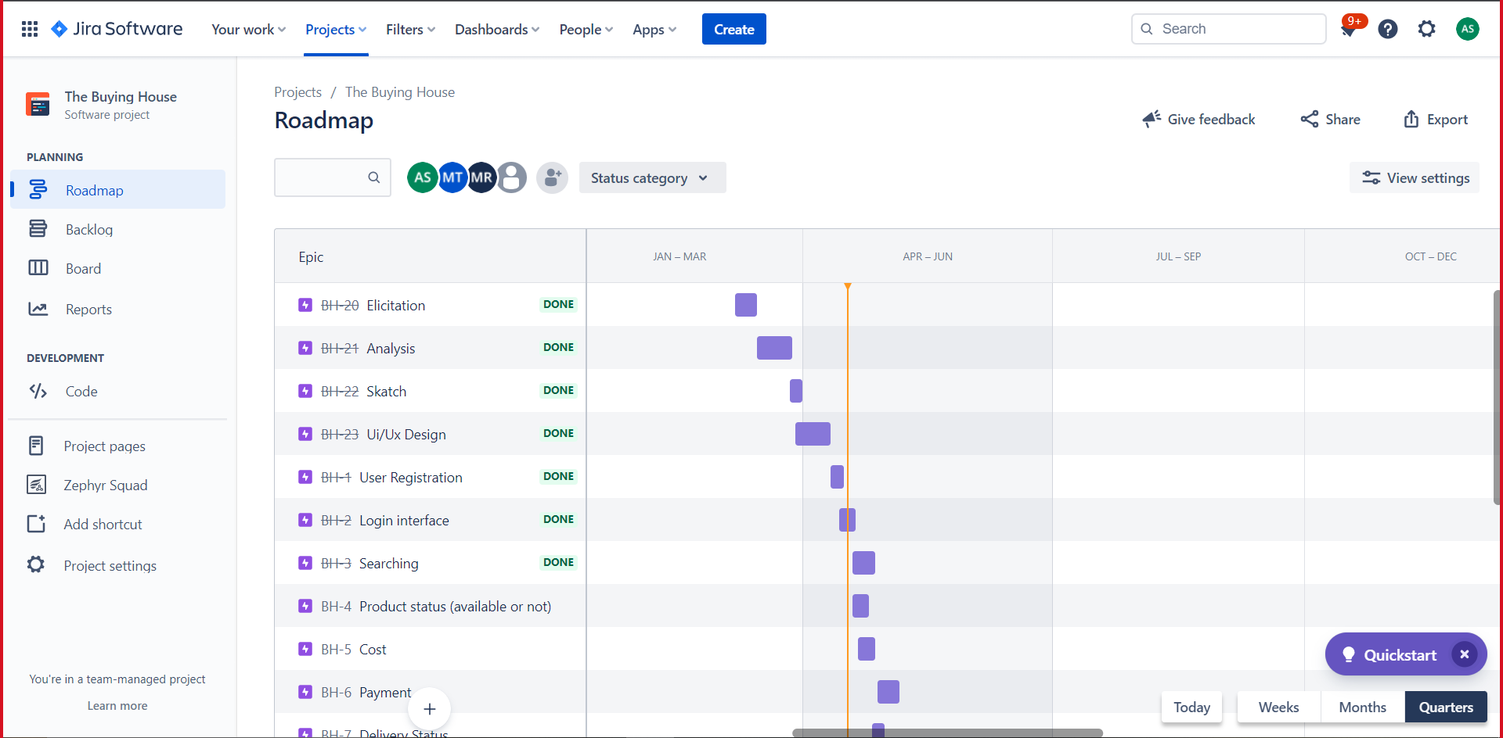

We started our elicitation part at 7th march and planning to finish the project with the review part on may 16th the full roadmap is on the figure 7.

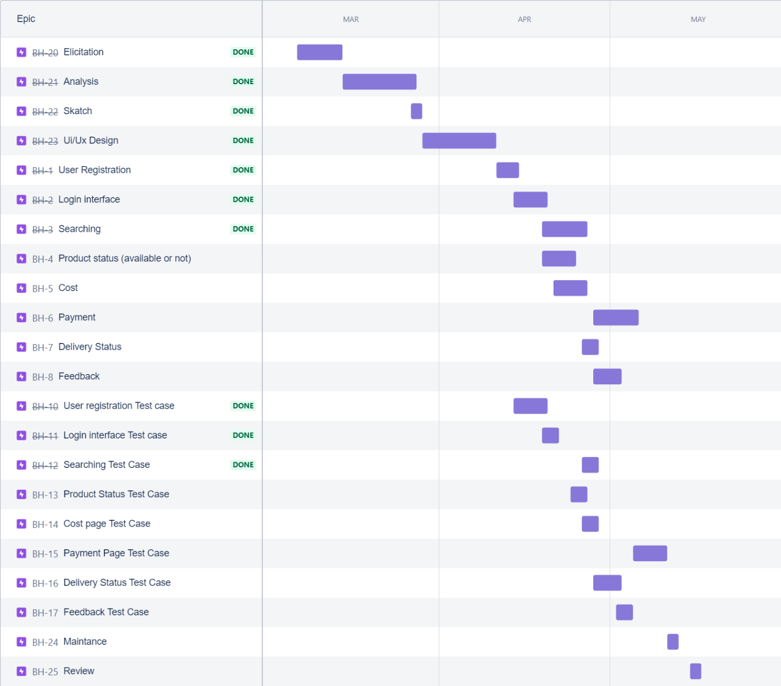

**Figure 6,7- Roadmap with Jira [3]**

A cumulative flow diagram is a tool used in queuing theory. It is an area graph that depicts the quantity of work in a given state, showing arrivals, time in queue, quantity in queue, and departure. Cumulative flow diagrams are seen in the literature of agile software development and lean product development.

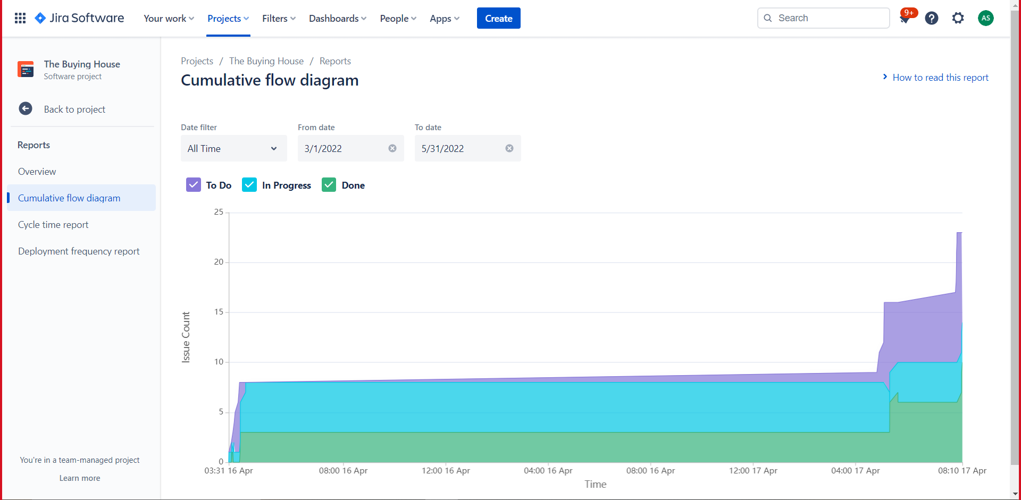**Figure 8-Cumulative flow diagram with Jira [3]**

# Development Plan

To develop our project the best suitable SDLC method is Agile Methodology.

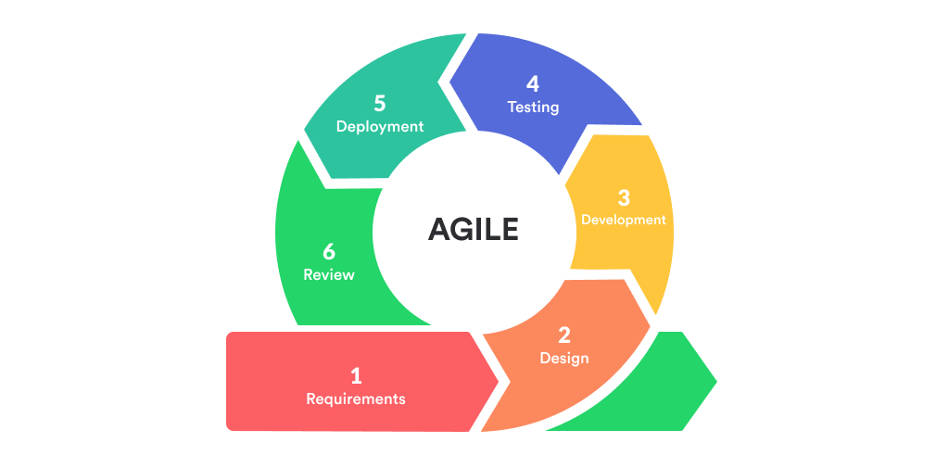

**Figure 9-Agile method lifecycle [1]**

## Stage 1: Requirement Analysis & Defining

**Analysis:** At first, we have to perform the elicitation part. After elicitation part, the most important part of any project is Planning and Requirement Analysis. Requirement analysis is the fundamental stage in SDLC. It will be performed by the product manager, leader of development team and leader of quality assurance with inputs from the customer, the sales department, market surveys and domain experts in the industry.

**Defining:** After the planning and requirement analysis part is done the second step will be to clearly define and document the product requirements and get them approved from the customer or the market analysts. This will be done through an SRS (Software Requirement Specification). It will be performed by the Business Analysist.

## Stage 2: Designing the Product Architecture

This often is called the design phase of the SDLC life cycle. The Software Requirement Specification document plays a key role as a reference for product architects to design a comprehensive product architecture. Based on requirements detailed, product architects may present multiple alternative architectures and codify this in a design specification. A thoroughly designed approach has to define all the architectural modules of the product along with its communication and data flow representation with external third party software modules if used.

## Stage 3: Building or Developing the Product

This is the stage of the SDLC where the real software development of the product or subsystem begins. A developer can code in a variety of high-level programming languages, including C++, Java, and PHP. The programming language is chosen to meet the software's requirements.

## Stage 4: Testing the Product

This is known as the testing phase. It is the more contemporary approach is to include unit test software modules as they are being coded and then wrap up with inter-module integration testing. Final testing takes into consideration top concerns including scale, network connectivity, and overall software reliability. The testing activities are mostly involved in all the stages of SDLC.

## Stage 5: Deployment and Maintenance

Once the product is tested, and ready to deploy it is released through a formal release mechanism that makes it available to end users. This mechanism may happen in planned release stages so that a succession of capabilities are introduced in a logical fashion that is easier for end users to consume. Once the product is released, it enters a maintenance mode until it reaches the end of its life cycle.

## Stage 6: Review

Review plays an important role in all the phases of SDLC cycle. It helps in minimizing the issues/defects in a particular phase and even in subsequent phases.

In this phase, we are reviewing **Functional Specification Document, High Level Design and Low-Level Design documents, Code review and the checklist** of **Code formatting, Architecture, Non-functional requirements and Testing.**

We are selecting SCRUM method From AGILE SDLC to complete our project. As the project is dividend in three phases including pregame, development and postgame which is inspired by the game rugby

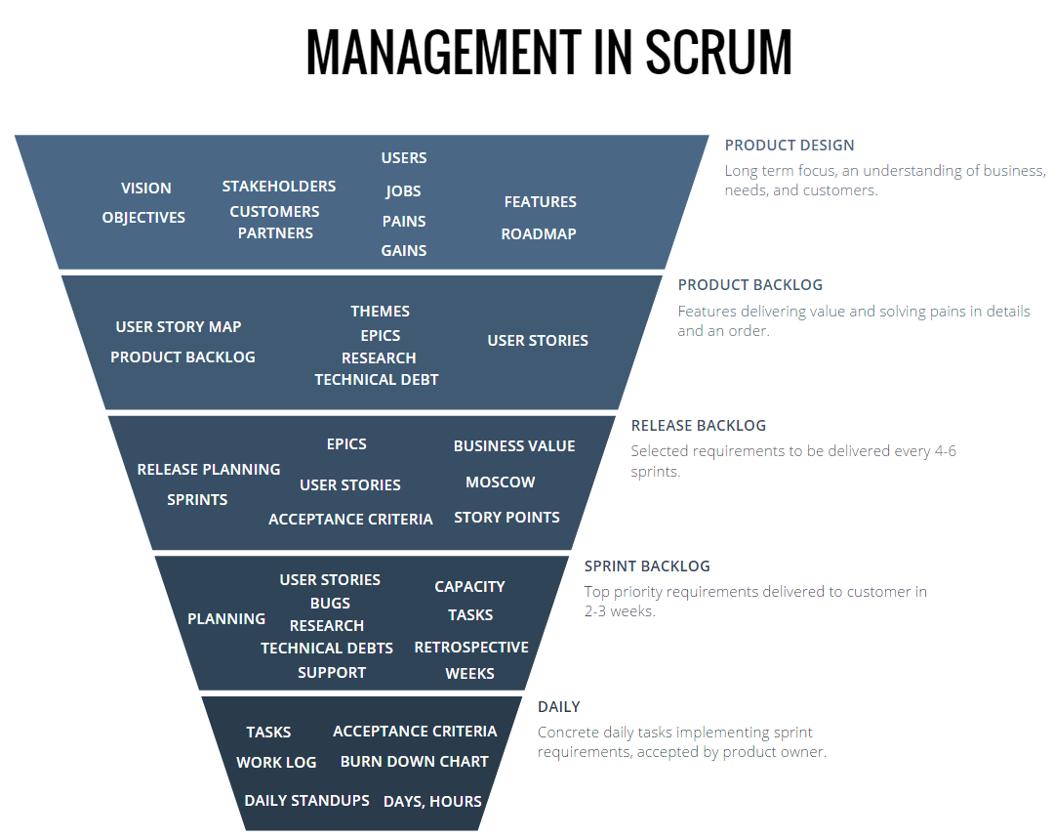

**Figure 10-Management in scrum [2]**

The Management will be in charge of final decision making, along with the agreements, standards, and conventions to be followed in the project. It will also participate in the setting of goals and requirements.

# Change Management Plan

We have to follow some policy for controlling changes. According to this, we have to make our own Change Control Policy.

* Every change must be noted in accordance and if it is not noted then the change will be not considered on the software.
* Unapproved change requests will not be performed like design, implementation and feasibility exploration.
* Simple changes request may not be grunted and will not be implemented except CCB will take the decision.
* Every change request process must be visible to all project stakeholders.
* The effect of every analysis must be performed for each and every change. Every include changes must be traceable for every approving change request Every change if it is approval or rejection must be recorded. Our Change control process will be followed by this diagram, which is given below:

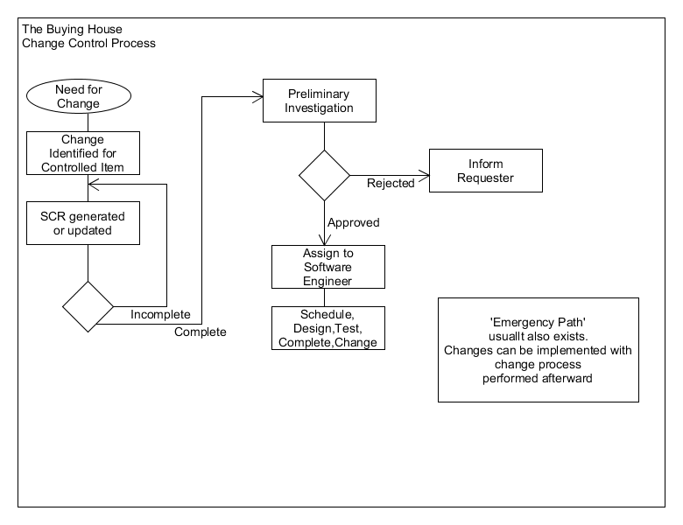

**Figure 11- Change control process [5]**

# Marketing Plan

After all portion, we have to make a good marketing plan so that every high- and low-level clients can see our planning. We understand how critical it is to develop tactics that will help us raise brand recognition and establish a corporate identity for our education-consulting firm. Our sales and marketing staff will be hired based on their extensive expertise in the area, and they will be trained on a regular basis to ensure that they are well equipped to fulfill their goals and the organization's overall objectives.

Our motive will be “**What is seen can be sold**”

For that, we have to do some planning like:

* Garments will add 10% extra price in our online based software and we will give discount to our client 10% on that pricing. Therefore, that garments and client’s price will be equal and we can get so promotion as well.
* For the first order garments don’t need to pay us and clients can use it as a free trail process so that they do not need to registration at first but if they want to order any product then they will have to do registration. So finally, can say that clients can overview the total software how it works.
* We can promote our service by YouTube advertisement and Facebook and twitter promotion. We can also promote our service on Television, we will make advertisement with higher celebrity so that every client notices our advertisement since this will have an attractive advertise.
* We will make advertise with different language so that clients can understand easily about our software.
* We will also make our software’s promotion as international level sports sponsors. So that we can gain the focus of our clients and public also.
* We will provide billboards in local places of every places to gain the focus of clints.

## Marketing Strategy for the Short Term:

A short-term marketing plan helps a firm achieve early momentum and traffic. Short-term success is crucial for any firm, especially in its early phases.

### Marketing on the Internet:

Sponsored social media advertising is another method for reaching out to new clients. We could perhaps boost our consumer base with Facebook, YouTube and Twitter advertise as well as other social media networks.

### Advertisements in the media:

In the media business, television has a major presence. As a result, television may become obsolete additional channel via which we may spread the word about our initiative newspapers and radio, Television, for example, plays an essential part in the media sector. As a result, newspapers and radio stations is another option for reaching out to new consumers.

## Marketing Strategy for the Long-Term:

Long-term marketing objectives are those that are met by a combination of long-term marketing techniques. Short-term gain will be addressed as well. Long-term marketing strategy might be the most essential component in a company's capacity to survive in the long run. Attracting the proper clients over time is crucial.

### Campaigns:

A campaign is any series of actions or events undertaken to achieve a specified goal. Ours, for example, will be a software advertising campaign. We will run this campaign in order to acquire greater public notice. This program will be carried out in all places where people move often.

### Billboards:

When social media was less prominent, one of the methods to promote was through billboards. As a consequence, billboards can help us with our marketing efforts. Pedestrians on the route will be drawn to it effortlessly.

### Search Engine Optimization (SEO):

Search Engine Optimization (SEO) is a strategy for helping people locate information that is more relevant to their search queries. For this aim, search engines like Google or Bing may be approached, and they can be encouraged to advertise our app and website more.

## Plan for Consistent Marketing:

Plan for Consistent Marketing: A company's or organization's continuous marketing plans are those that are used from the beginning to the conclusion of its life. This is the most essential of all the marketing plans included since it mixes short- and long-term strategies and proves to be a company's lifespan in terms of client acquisition.

### Account on social media:

First and foremost, we must develop our own social media account, where we will post all necessary product information. There will also be a link to our website so that anyone who is interested may go there right away. Some employees will be assigned to post on the company's social media account, and they will aim to engage with consumers by doing so on a regular basis, publishing product-related information Any customer who wants additional information can contact the page by sending a message. We will do everything we can to react to their communications as soon as feasible. Employees will share the meeting photos or short clips in the social platform that will help the marketing growth.

### Promotional Film:

A promotional video is a great way to get the word out to the general audience about a current product. There are some well-known influencers with big followings in our country. They make commercials for a wide range of items. They may also be able to help us make a promotional film for our goods.

# Cost and Profit Analysis

## Development cost:

|  |  |  |  |
| --- | --- | --- | --- |
| **Role** | **Quantity** | **Time (hours)** | **Salary** |
| Sr. Business Analyst | 1 | 46 | $4,600 |
| Jr. Analyst | 1 | 13 | $910 |
| Manager | 1 | 49 | $5,880 |
| Designer | 1 | 69 | $3,450 |
| Lead Developer | 1 | 10 | $1,500 |
| Developer | 3 | 336 | $21,640 |
| Lead QA | 1 | 8 | $840 |
| QA | 3 | 272 | $18,600 |
| **Total Salary Cost** | | | **$57,420** |

## Marketing Cost:

### Short Term Marketing Cost:

|  |  |  |  |
| --- | --- | --- | --- |
| **Plan** | **Time (Months)** | **Cost (Per Month)** | **Total cost** |
| Digital Marketing | 3 | $300 | $900 |
| Media Advertising | 6 | $550 | $3,300 |
| **Total Short Term Marketing Cost** | | | **$4,200** |

### Long Term Marketing Cost:

|  |  |  |  |
| --- | --- | --- | --- |
| **Plan** | **Time (Months)** | **Cost (Per month)** | **Total cost** |
| Campaign | 12 | $650 | $7,800 |
| Bill-Boards | 10 | $550 | $5,500 |
| Search Engine Optimization | 20 | $300 | $6,000 |
| **Total Long Term Marketing Cost** | | | **$19,300** | |

### Continuous Marketing Cost:

|  |  |  |  |
| --- | --- | --- | --- |
| **Plan** | **Time (Years)** | **Cost (Per year)** | **Total cost** |
| Social-Media | 5 | $800 | $4,000 |
| Promotional Video | 1.5 | $1,500 | $2,250 |
| **Total Continuous Marketing Cost** | | | **$6,250** | |

**Total Cost:**

Development Collaboration Cost + Short Term Marketing Cost + Long Term Marketing Cost + Continuous Marketing Cost = **$87,170**

## Profit:

Seals = Purchase * 10% Development

For example,

If, A client Purchase, = $500,000, Then our sell will be = $50,000

If, A client Purchase = $1,000,000, Then our sell will be = $1,00,000

If, A client Purchase = $1,500,000, Then our sell will be = $1,50,000

If, A client Purchase = $10,000, Then our sell will be = $1,000

If, A client Purchase = $50,000, Then our sell will be = $5,000

Total purchase $3,060,000, Total Sell $306,000

Profit = $ (Total sell - Total Cost)

= **$306,000 - $ 87,170**

= **$218,830**

## Analysis:

From Cost and Profit Analysis we have get our profit, which is 218,830. If client purchase $3,060,000 from the manufacturer, then manufacturer have to pay us $306,000. Our total cost to development and marketing is $87,170. So, our profit will be count as minimized from total sell to total cost and that is $306,000 to 87,170 and finally our profit will be $218,830. This is only 5 purchase calculation has been shown. Average per day if 5 order can procedure then the profit will be per day 218,830. For per month the profit will be about (30*218,830) = 6,564,900.

From a real data about BGMEA says that Apparel exports fetched Bangladesh US$31.76 billion during January-to-November period of 2021 calendar year, recording a 28-per cent growth over $24.81 billion earned during the corresponding period of 2020, according to the industry account. The Bangladesh Garment Manufacturers and Exporters Association (BGMEA) data show the earning at US$33.07 billion in 2019 and down at $27.47 billion in 2020-the year of corona onslaughts.**[6]**

# Reference

[1][https://www.google.com/imgres?imgurl=https://miro.medium.com/max/848/0*RziwSIdYb2capKWN.png&imgrefurl=https://mzuhdiz.medium.com/agile-software-development-a-game-changer-of-software-development-process-d52933246c28&tbnid=OXoxDPG2Tva2NM&vet=1&docid=dHq6YywhF0H0eM&w=848&h=418&source=sh/x/im](https://www.google.com/imgres?imgurl=https://miro.medium.com/max/848/0*RziwSIdYb2capKWN.png&imgrefurl=https://mzuhdiz.medium.com/agile-software-development-a-game-changer-of-software-development-process-d52933246c28&tbnid=OXoxDPG2Tva2NM&vet=1&docid=dHq6YywhF0H0eM&w=848&h=418&source=sh/x/im)

[2]<https://www.google.com/imgres?imgurl=https://www.scrumdesk.com/wp-content/uploads/Management-in-Scrum.png&imgrefurl=https://www.scrumdesk.com/start/manual-for-scrumdesk-start/management-in-scrum/&tbnid=ozyJy4wnqtwNDM&vet=1&docid=fboE9keeYNRfBM&w=1079&h=859&source=sh/x/im>

[3]<https://www.atlassian.com/software/jira?gclsrc=aw.ds&&aceid=&adposition=&adgroup=95003642769&campaign=9124878693&creative=444941494265&device=m&keyword=%2Bjira&matchtype=b&network=g&placement=&ds_kids=p51394879819&ds_e=GOOGLE&ds_eid=700000001558501&ds_e1=GOOGLE&gclid=Cj0KCQjwmPSSBhCNARIsAH3cYgZ1bHozbzQ5tTG-NoWAfPzxuD0B_5_b7oaTeYrVliU5EEjToAxQzu4aAqFEEALw_wcB>

[4]<https://www.google.com/imgres?imgurl=https://www.devteam.space/wp-content/uploads/2017/09/project-estimation.jpg&imgrefurl=https://www.devteam.space/blog/how-to-estimate-projects-techniques-methods/&tbnid=2698xwKdARql7M&vet=1&docid=miR088uEM0oXGM&w=638&h=479&source=sh/x/im>

[5]<https://www.google.com/imgres?imgurl=https://www.slideteam.net/media/catalog/product/cache/1280x720/c/o/cost_benefit_analysis_template_development_ppt_powerpoint_presentation_pictures_slide01.jpg&imgrefurl=https://www.slideteam.net/business_powerpoint_diagrams/catalog/product/view/_ignore_category/1/id/196669/s/cost-benefit-analysis-template-development-ppt-powerpoint-presentation-pictures/&tbnid=V3vAgZjSEnwcVM&vet=1&docid=YXRz1u70JF_ZCM&w=960&h=720&source=sh/x/im>

[6]<https://thefinancialexpress.com.bd/trade/apparel-makers-reassert-reign-in-2021-1640919431>